3. Fibonacci series

<!DOCTYPE html>

<html>

<body>

<script>

var a=0,b=1,c;

var inputNumber=prompt("Please enter fibonacci range number");

document.write("Fibonacci series :");

document.write("<br/>");

document.write(a);

document.write("<br/>");

document.write(b);

if(inputNumber!=undefined && !isNaN(inputNumber))

{

while (b<=parseInt(inputNumber))

{

if(c!=undefined)

document.write(c);

document.write("<br/>");

c=a+b;

a=b;

b=c;

}

}

</script>

</body>

</html>

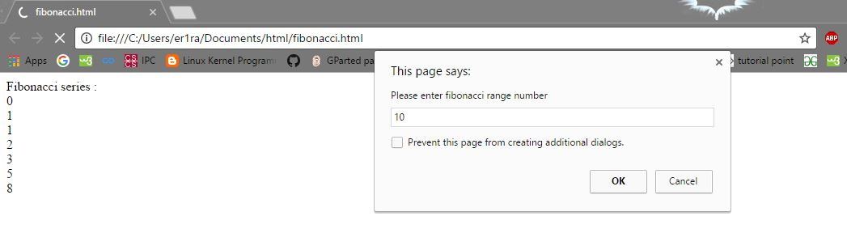

4. Factorial of a Number

<!DOCTYPE html>

<html>

<head>

<script>

function factorial(f,n)

{

l=1;

for(i=1;i<=n;i++)

l=l\*i;

f.p.value=l;

}

</script>

</head>

<body>

<form>

Input Number:<input type="text" name="t"></br>

<input type="button" value="submit" onClick="factorial(this.form,t.value)"></br>

Factorial :<input type="text" name="p"></br>

</form>

</body>

</html>

